ASSIGNMENT 4

|  |  |
| --- | --- |
| Date | 21 October 2022 |
| Student Name | DHARSHINI.K.M |
| Student Register Number | 211419106065 |
| Maximum Marks | 2 Marks |

**WOKWI WEB URL:**

<https://wokwi.com/projects/347761369240568404>

SNAPSHOTS OF SIMULATION:

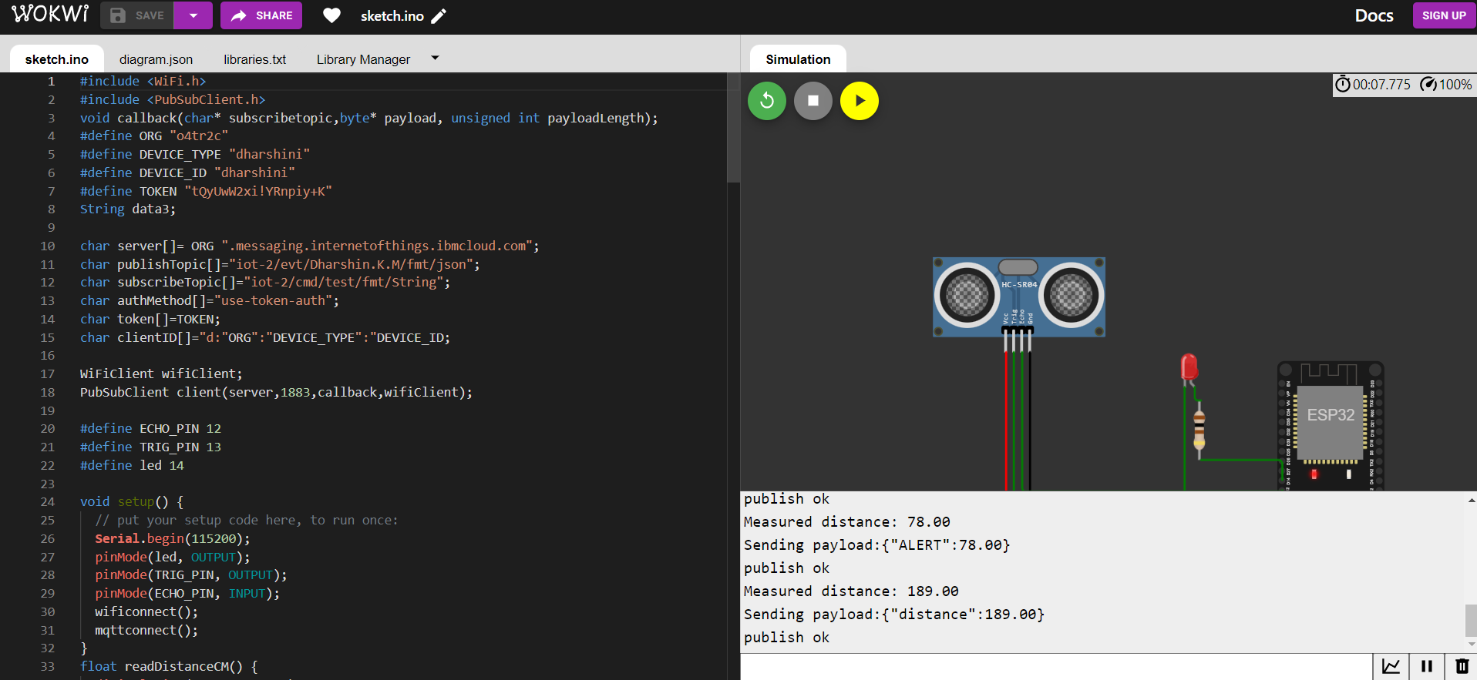

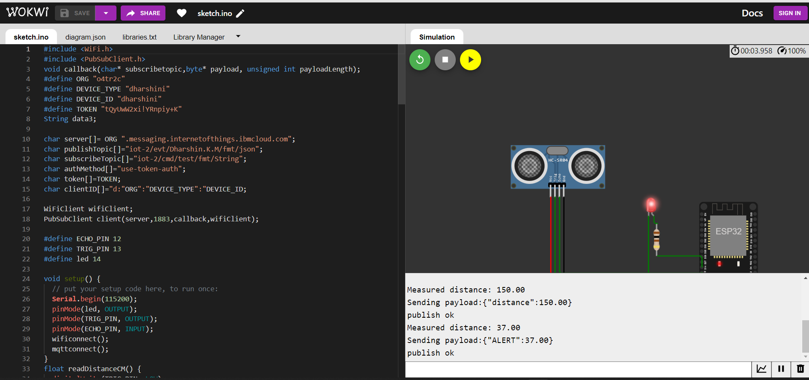

**IMAGES OF IBM CLOUD:**

